**Agile Use Cases**

**for the**

**SIUE Department of Computer Science**

**CS425 / CS499 Senior Project**

**Software Design and Implementation Courses**

**by**

**Zach Benchley, Matt Lievens, Logan Maughan, Brian Olsen**

**of**



**Learning Outcomes-Based Assessment Database Team**

Revision 1.0

As Of: September 16, 2013

LOBA-SPEC-AUC

**Change Log:**

|  |  |
| --- | --- |
| Revision | Change Note(s) |
|  |  |
| 1.0 | * Initial Release |

Reviewed and Approved By:

Name Signature Date

## **Table of Contents**

1. Teacher Creates Class ........................................................................................................................4
2. Teacher Selects Class .........................................................................................................................6
3. Teacher Adds Student ........................................................................................................................8
4. Teacher Removes Student ...............................................................................................................10
5. Teacher Adds Student Scores ...........................................................................................................12
6. Teacher Change Student Scores .......................................................................................................14
7. Teacher Prefills Outcomes ...............................................................................................................16
8. Students View Masteries .................................................................................................................18
9. Teacher Adds a Skill ..........................................................................................................................20
10. Teacher Removes a Skill ...................................................................................................................22
11. Teacher Views Skills .........................................................................................................................24
12. Student Views Assignment Breakdowns ..........................................................................................26
13. Scores Stored in Database ...............................................................................................................28
14. Teacher Exports Scores in Delimited Form ......................................................................................30
15. Teacher Adds a Question to an Assignment ....................................................................................32
16. Teacher Removes a Question from an Assignment .........................................................................34
17. Teacher Adds an Assignment to a Class ...........................................................................................36
18. Teacher Removes an Assignment from a Class ................................................................................38
19. Teacher Removes a Class .................................................................................................................40

## **List of Figures**

Figure 1: Create a Class Use Case Diagram ..................................................................................................5

Figure 2: Select a Class Use Case Diagram ...................................................................................................7

Figure 3: Teacher Adds Student Use Case Diagram .....................................................................................9

Figure 4: Teacher Removes Student Use Case Diagram ............................................................................11

Figure 5: Teacher Adds Student Scores Use Case Diagram ........................................................................13

Figure 6: Teacher Changes Student Scores Use Case Diagram ..................................................................15

Figure 7: Teacher Prefills Outcomes Use Case Diagram ............................................................................17

Figure 8: Students View Masteries Use Case Diagrams .............................................................................19

Figure 9: Teacher Adds a Skill Use Case Diagram .......................................................................................21

Figure 10: Teacher Removes Skill Use Case Diagram .................................................................................23

Figure 11: Teacher Views Skills Use Case Diagram ....................................................................................25

Figure 12: Student Views Breakdowns Use Case Diagrams .......................................................................27

Figure 13: Scores Stored in Database Use Case Diagram ...........................................................................29

Figure 14: Teacher Exports Scores Use Case Diagram ...............................................................................31

Figure 15: Teacher Adds Questions to Assignment Use Case Diagram .....................................................33

Figure 16: Teacher Removes a Question Use Case Diagram ......................................................................35

Figure 17: Teacher Adds an Assignment Use Case Diagram ......................................................................37

Figure 18: Teacher Removes an Assignment Use Case Diagram ...............................................................39

Figure 19: Teacher Removes a Class Use Case Diagram ............................................................................41

|  |  |
| --- | --- |
| Use Case Name: | Teacher creates a new class. |
| Related Requirements: | Removing classes, adding students to a class, removing students from a class |
| Goal in Context: | Used at the beginning of each semester to add each class the instructor will be teaching to the LearnOBA software system. |
| Preconditions: | LeranOBA must be installed on the instructor’s computer. |
| Successful End Condition: | Class is successfully added to the system for the right year and semester. |
| Failed End Condition: | Class was not added to the system. Class was added to the wrong year/semester. |
| Primary Actors: | Instructor |
| Secondary Actors: | LearnOBA database |
| Trigger: | Start of the semester. Teacher decides to start teaching a new class. |
| Main Flow: | 1)Start of the new semester  2)Teacher starts up LearnOBA  3)Teacher selects to create a new classs  4)Teacher selects the year and term  5)Teacher enters the class information  6)Teacher presses save to save to DB |
| Extensions: | N/A |

## 1 Teacher Creates Class

Scenario: Dr. Foster is a physics teacher at Southern Illinois University at Edwardsville. It is that time of year again for classes to come back into session. Dr. Foster loves using the LearnOBA software system for implementing his LOBA (Learning Based Outcome Assessment) style of grading. In order to keep track of his students’ grades for this semester the students must be entered into the LearnOBA system. Dr. Foster does this very easily by interacting with his user face and creating a new class for the specific year and semester.

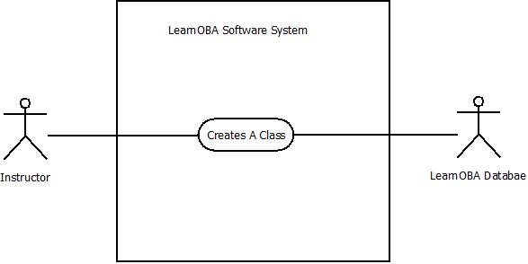

### Figure 1: Create a Class Use Case Diagram

# 2 Teacher Selects Class

|  |  |
| --- | --- |
| Use Case Name: | Teacher selects a class. |
| Related Requirements: | Adding students, removing students, removing class |
| Goal in Context: | Teacher selects a specific class to edit the students in the class or to remove that class. |
| Preconditions: | LeranOBA must be installed on the instructor’s computer and class has to have been added. |
| Successful End Condition: | Class is successfully selected by the instructor. |
| Failed End Condition: | Class was not selected correctly. |
| Primary Actors: | Instructor |
| Secondary Actors: | N/A |
| Trigger: | Teacher decides to add or remove a student. Teacher wants to edited the outcomes of the students. |
| Main Flow: | 1)Teacher starts up LearnOBA  2)Teacher chooses to select a class.  3)Teacher selects the class from a given year and semester. |
| Extensions: | N/A |

Scenario: Mrs. Ham has just been given the news that a new student has been added to her class. In order to keep track of the new students’ grades she needs to add him/her to the LearnOBA system. Mrs. Ham boots up the software system and simply selects the class the new student will be attending. She then goes ahead and adds the student to the class.

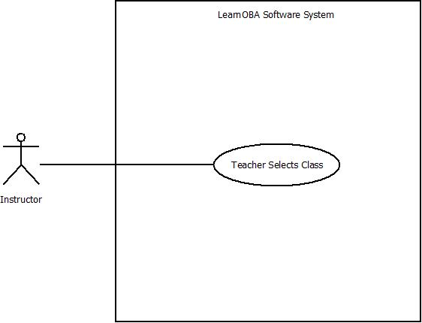

### Figure 2: Select a Class Use Case Diagram

# 3 Teacher Adds Student

|  |  |
| --- | --- |
| Use Case Name: | Add Student to the Class |
| Related Requirements: | Modifying outcomes for the student |
| Goal in Context: | A student is added to a specific class so that their outcomes can be entered. |
| Preconditions: | LeranOBA must be installed on the instructor’s computer and class has to have been added. |
| Successful End Condition: | Student is successfully added to the class. |
| Failed End Condition: | Student was not successfully added to the class. |
| Primary Actors: | Instructor |
| Secondary Actors: | Student, Database |
| Trigger: | Student asks to be added to a class. |
| Main Flow: | 1)Student asks to be added to the class.  2) Teacher grants permission and starts up LearnOBA.  3)Teacher selects a specific class.  4) Teacher selects to add a student to a specific class.  5)Teacher fills out student info.  6) Teacher saves student to database. |
| Extensions: | N/A |

Scenario: After class a student approaches Dr. McKenney saying they have been waitlisted for his Database Management class. Dr. McKenney decides to be a nice guy and let the student join the class. Dr. McKenney goes back to his office and starts up LearnOBA. Using the interface, Dr. McKenney selects the appropriate class and chooses to add a student. He enters the student’s information and clicks save. The student is now saved to the database.

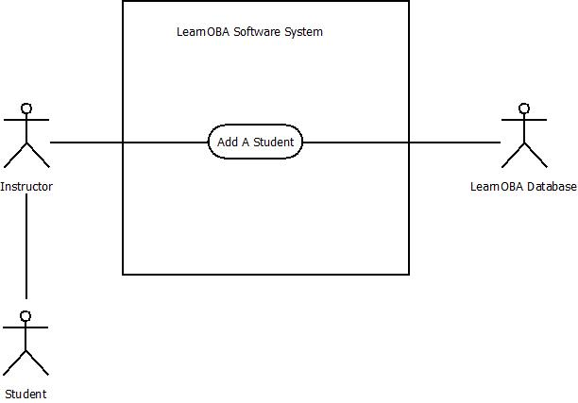

### Figure 3: Teacher Adds Student Use Case Diagram

# 4 Teacher Removes Student

|  |  |
| --- | --- |
| Use Case Name: | Remove student from the class |
| Related Requirements: |  |
| Goal in Context: | A student is removed from a specific class. |
| Preconditions: | LeranOBA must be installed on the instructor’s computer and class has to have been added, and a student must have been added to that class. |
| Successful End Condition: | Student is successfully removed from a class. |
| Failed End Condition: | Student was not successfully removed from the class. |
| Primary Actors: | Instructor |
| Secondary Actors: | Student, Database |
| Trigger: | Student asks to be removed from a class. Student breaks a university rule and is dismissed from the class. |
| Main Flow: | 1)Student asks to be dropped from the class.  2) Teacher grants permission and starts up LearnOBA.  3)Teacher selects a specific class.  4) Teacher selects to remove a student from a specific class.  6) Teacher removes student to database. |
| Extensions: | 1.1 Student breaks rules and must be removed. |

Scenario: A few weeks have gone by during the semester. A student has approached Dr. White about his grade because he is currently receiving a grade of 35%. The student asks Dr. White if he can be dropped from the course so the course grade does not affect his GPA. Dr. White chuckles to himself and says, “Yes! Another student has fell victim to my grading scheme. Of course you can drop it.” So, Dr. White goes and starts up LearnOBA. He selects the class the student wishes to be dropped from. He then selects the students name and clicks to remove the student from the class.

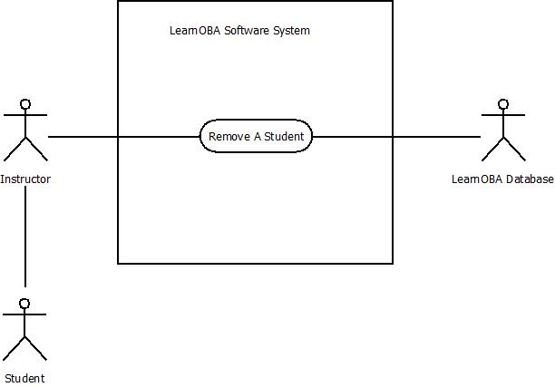

### Figure 4: Teacher Removes Student Use Case Diagram

# 5 Teacher Adds Student Scores

Scenario: Dr. Foster has just graded Matt’s test for his PHYS 151 class. It is now time to add the results of the test into his LearnOBA application. He starts up LearnOBA and navigates to PHYS 151 class. Once there Dr. Foster finds Matt’s name in the list of students for the class and brings up his Score history. He then navigates to the first task on the test and places the scores into the student’s outcomes for that task.

|  |  |
| --- | --- |
| Use Case Name: | Instructor add student scores |
| Related Requirements: | The Instructor wants to be able to add student scores so that the student’s progress can be accurately tracked. |
| Goal in Context: | Add Student’s scores to LearnOBA |
| Preconditions: | LearnOBA must be installed on the instructor’s computer, students must be added to class, tasks must be added for student in class |
| Successful End Condition: | Score successfully added into database |
| Failed End Condition: | Score not successfully added into database |
| Primary Actors: | Instructor |
| Secondary Actors: | Database |
| Trigger: | Instructor grades task and is ready to submit scores to LearnOBA |
| Main Flow: | 1) Instructor starts up LearnOBA  2) Instructor Navigates to correct class  3) Instructor Navigates to correct student and task  4) Instructor enter the student’s score into LearnOBA |
| Extensions: | N/A |



### Figure 5: Teacher Adds Student Scores Use Case Diagram

# 6 Teacher Change Student Scores

Scenario: Dr. Foster has just finished grading the first test for his PHYS 151 class. Now that he has finished grading he realizes that the first question on the test did not really reflect one of the skills that he had meant it too. He starts up LearnOBA and navigates to PHYS 151 class. Once there Dr. Foster goes through all of the students in the list of students for the class and brings up their Score histories. He then navigates to the first task on the test and removes the scores from the student’s outcomes for that task.

|  |  |
| --- | --- |
| Use Case Name: | Instructor changes student scores |
| Related Requirements: | The Instructor wants to be able to change student scores. |
| Goal in Context: | Change Student’s scores in LearnOBA |
| Preconditions: | LearnOBA must be installed on the instructor’s computer, students must be added to class, tasks must be added for student in class |
| Successful End Condition: | Score successfully changed in database |
| Failed End Condition: | Score not successfully changed in database |
| Primary Actors: | Instructor |
| Secondary Actors: | Database |
| Trigger: | Instructor grades task and is ready to submit scores to LearnOBA |
| Main Flow: | 1) Instructor starts up LearnOBA  2) Instructor Navigates to correct class  3) Instructor Navigates to correct student and task  4) Instructor changes the student’s score in LearnOBA |
| Extensions: |  |



### Figure 6: Teacher Changes Student Scores Use Case Diagram

# 7 Teacher Prefills Outcomes

Scenario: Dr. Foster is writing the 3rd test of the year for his PHYS 151 class. By this point in the class he believes that the students should all be able to get the max possible score in some of the more basic skills (like writing units) in the class. Because of this, for any new task that has writing units as a skill Dr. Foster places the highest possible score in the outcome for that task. Later, when he grades the tests, he will only have to change the outcome for the writing units skill, when a student did not write the unit.

|  |  |
| --- | --- |
| Use Case Name: | Outcomes can be prefilled |
| Related Requirements: | The Instructor wants to be able to pre-fill all of the outcomes for a task so that progress tracking and score updating is easier. |
| Goal in Context: | Pre-fill all of the outcomes for a task |
| Preconditions: | LearnOBA must be installed on the instructor’s computer, students must be added to class, tasks must be added for student in class |
| Successful End Condition: | Specific outcomes for a specified task get pre-filled for all students |
| Failed End Condition: | Specific outcomes for a specified task fail to be pre-filled for all students |
| Primary Actors: | Instructor |
| Secondary Actors: | Database |
| Trigger: | Instructor decides to pre-fill specific outcomes for a specified task |
| Main Flow: | 1) Instructor starts up LearnOBA  2) Instructor Navigates to correct class  3) Instructor creates a task  4) Instructor enter the pre-filled score into a specific Outcome for the new task |
| Extensions: | N/A |



### Figure 7: Teacher Prefills Outcomes Use Case Diagram

# 8 Students View Masteries

Scenario: Matt wants to know how he is currently doing in his PHYS 151 class. Matt then logs into Black Board, and can now view all his masteries, giving him a good understanding of where he stands in the class.

|  |  |
| --- | --- |
| Use Case Name: | Students View Masteries |
| Related Requirements: | The students need to be able to view their current masteries. |
| Goal in Context: | Enable Students to view their masteries |
| Preconditions: | Instructor exports masteries to Blackboard |
| Successful End Condition: | Student views their current masteries |
| Failed End Condition: | Student fails to view their current masteries |
| Primary Actors: | Student |
| Secondary Actors: | Blackboard |
| Trigger: | Student logs on Blackboard to view masteries |
| Main Flow: | 1) Student logs into blackboard.  2)Student views masteries. |
| Extensions: | N/A |



### Figure 8: Students View Masteries Use Case Diagrams

# 9 Teacher Adds a Skill

Scenario: Dr. Crk realizes that he left the “Multithreading” skill off of the list of skills for his Topics in Distributed Computing course. He understands that this is a core concept for the class and it is important for each of his students to master this skill. Dr. Crk goes to his computer and starts up LearnOBA. He selects the appropriate class and pulls up the skill list for that class. He then proceeds to add “Multithreading” to the skill list. When finished, he saves the new skill list to the database.

|  |  |
| --- | --- |
| Use Case Name: | Add a Skill |
| Related Requirements: | Remove a Skill, View Skills |
| Goal in Context: | To add a skill to the list of skills for a specific class. |
| Preconditions: | LearnOBA must be installed on the instructor’s computer. |
| Successful End Condition: | Skill is successfully added to the list |
| Failed End Condition: | Skill is not successfully added to the list |
| Primary Actors: | Instructor |
| Secondary Actors: | Database |
| Trigger: | Teacher wants their students to learn a skill that is not on the list. |
| Main Flow: | 1) Teacher wants students to learn a skill that is not on the list  2) Teacher starts up LearnOBA  3) Teacher selects the appropriate class  4) Teacher opens up master list of skills for that class  5) Teacher selects to add a skill to the list  6) Teacher types in the name of the skill  7) Teacher saves the new skill list to the database. |
| Extensions: | N/A |

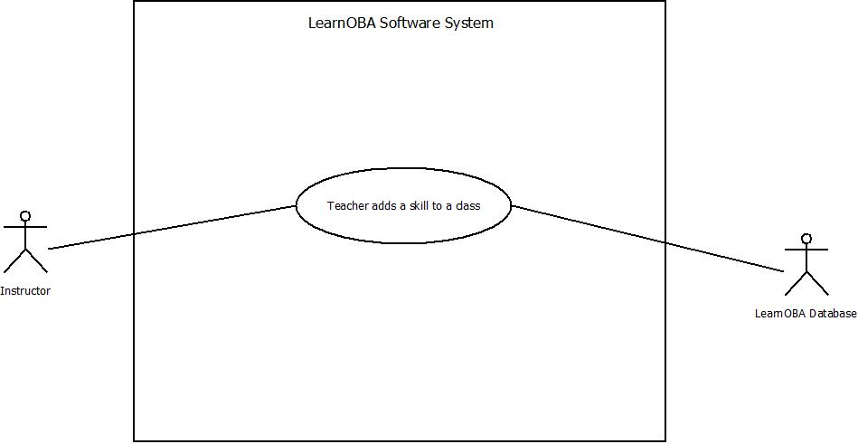

### Figure 9: Teacher Adds a Skill Use Case Diagram

# 10 Teacher Removes a Skill

Scenario: Due to time constraints, Dr. White no longer wishes his Human-Computer Interaction Design class to master the skill called “Work Models”. In order to prevent confusion between him and his students, he decides to remove the skill from the skill list. Dr. White goes to his computer and starts up LearnOBA. He selects the appropriate class and pulls up the skill list for that class. He then proceeds to remove “Work Models” from the skill list. When finished, he saves the new skill list to the database.

|  |  |
| --- | --- |
| Use Case Name: | Remove a Skill |
| Related Requirements: | Add a Skill, View Skills |
| Goal in Context: | To remove a skill from the list of skills for a specific class. |
| Preconditions: | LearnOBA must be installed on the instructor’s computer and a list of skills must have been created. |
| Successful End Condition: | Skill is successfully removed from the list |
| Failed End Condition: | Skill is not successfully removed from the list |
| Primary Actors: | Instructor |
| Secondary Actors: | Database |
| Trigger: | Teacher does not need to teach a skill that is on the list |
| Main Flow: | 1) Teacher does not need to teach a skill that is on the list  2) Teacher starts up LearnOBA  3) Teacher selects the appropriate class  4) Teacher opens up list of skills for that class  5) Teacher selects to remove a skill from the list  6) Teacher selects the skill they want to remove  7) Teacher removes the selected skill from the list  8) Teacher saves new skill list to the database. |
| Extensions: | N/A |

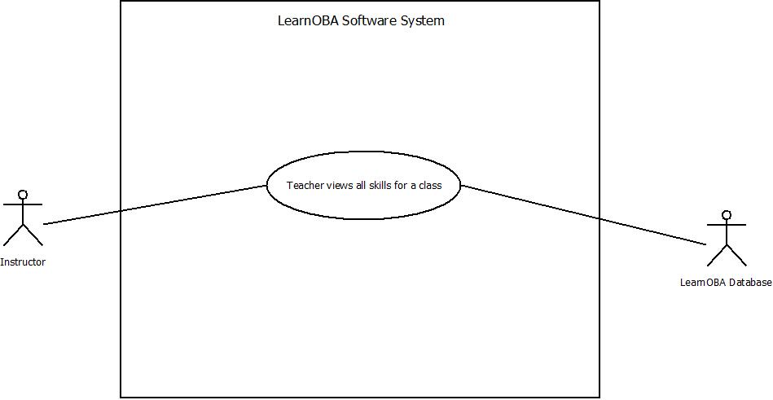

### Figure 10: Teacher Removes Skill Use Case Diagram

# 11 Teacher Views Skills

Scenario: Dr. McKenney cannot remember what skills he added to his Database Management Systems class. He decides to pull up the list in order to refresh his memory. Dr. McKenney goes to his computer and starts up LearnOBA. He selects the appropriate class and pulls up the skill list for that class.

|  |  |
| --- | --- |
| Use Case Name: | View Skills |
| Related Requirements: | Add a Skill, Remove a Sill |
| Goal in Context: | To view a list of all skills for a specific class. |
| Preconditions: | LearnOBA must be installed on the instructor’s computer and a list of skills must have been created. |
| Successful End Condition: | Skill list is successfully viewed |
| Failed End Condition: | Skill list is not successfully viewed |
| Primary Actors: | Instructor |
| Secondary Actors: | Database |
| Trigger: | Teacher wishes to view the skills for a class |
| Main Flow: | 1) Teacher wishes to view the skills for a class  2) Teacher starts up LearnOBA  3) Teacher selects the appropriate class  4) Teacher opens up master list of skills for that class |
| Extensions: | N/A |



### Figure 11: Teacher Views Skills Use Case Diagram

# 12 Student Views Assignment Breakdowns

|  |  |
| --- | --- |
| Use Case Name: | Student Views Breakdowns |
| Related Requirements: | N/A |
| Goal in Context: | A customized detailed report is generated from the LearnOBA system and students will be able to view the report that shows the scoring for their levels of mastery. |
| Preconditions: | LearnOBA must be installed on the instructor’s computer and class has to have been added, the assessment must have been taken and graded. |
| Successful End Condition: | Student can view a detailed report and have a better understanding of why they are doing well or poorly. |
| Failed End Condition: | Professor isn’t able to export the file or the data is displayed in a confusing and unreadable manner. |
| Primary Actors: | Instructor |
| Secondary Actors: | Student |
| Trigger: | An assessment has occurred that requires the attention of the student. |
| Main Flow: | 1)Teacher starts up LearnOBA  2) Teacher loads data into LearnOBA from assessment.  3)Teacher exports the detailed report.  4) Teacher gives the report to the students. |
| Extensions: | 3.1)Teacher has issues creating the report. |

Scenario: Mr. Tornaritis gave a quiz last week and wants to give his students an up-to-date detailed report of which skills are improving and which skills are not. After he updates the information from the quiz, he exports the data from the LearnOBA into a customized report to display specific metrics and messages about what needs to be improved. The students can then look at what skills they have a low level of mastery in, and study material related to those skills to increase his mastery on the following assessment.

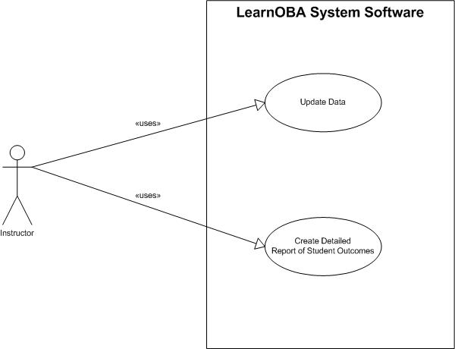

### Figure 12: Student Views Breakdowns Use Case Diagrams

# 13 Scores Stored in Database

Scenario: Dr. McKenney wants to back up his class information so he can assess the areas in his class that students struggle with. He uses LearnOBA to back up all the information from each class for two years. After this Dr. McKenney retrieves the information backed up from the past two years and averages each skill and looks for which skill has the lowest average of mastery.

|  |  |
| --- | --- |
| Use Case Name: | Scores Stored in Database |
| Related Requirements: | N/A |
| Goal in Context: | Back up class information into database. |
| Preconditions: | LearnOBA and a MySQL database must be installed on the instructor’s computer and class has to have been added, and two year have to have gone by. During these years the professor must save information on the class. |
| Successful End Condition: | The professor can back up and recall information from the database. |
| Failed End Condition: | The professor cannot backup nor access data to the database. |
| Primary Actors: | Instructor |
| Secondary Actors: | Database |
| Trigger: | Professor wishes to recall classes after semesters are over. |
| Main Flow: | 1)Teacher starts up LearnOBA  2) Teacher loads data into LearnOBA from assessment.  3)Teacher pushes data into the database through LearnOBA.  4)Later Data can be retrieved and filtered through the LearnOBA interface. |
| Extensions: | 3.1) Teacher has issues establishing a connection with the database.  3.2) The query fails in the database. |

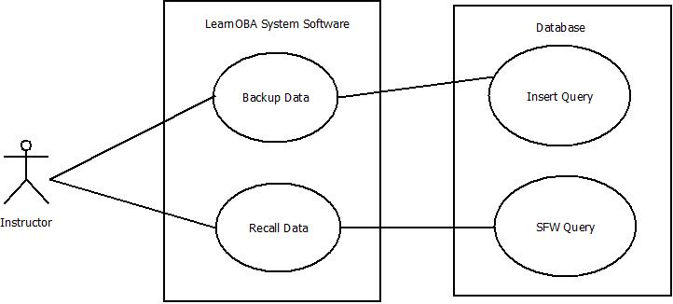

### Figure 13: Scores Stored in Database Use Case Diagram

# 14 Teacher Exports Scores in Delimited Form

Scenario: Mr. Tornaritis wants to export the scores from the last exam he gave. He exports the data from the LearnOBA, in a comma delimited file. After he updates the excel file he is able to upload it to the Blackboard interface.

|  |  |
| --- | --- |
| Use Case Name: | Teacher exports scores in delimited form |
| Related Requirements: | N/A |
| Goal in Context: | Instructor wishes to update the scores on Blackboard, for students to view, from information saved in LearnOBA. |
| Preconditions: | LearnOBA must be installed on the instructor’s computer and class has to have been added, and there must be accumulated data on the system. |
| Successful End Condition: | Instructors can export a delimited file of mastery scores. |
| Failed End Condition: | Technical difficulty with exporting file. |
| Primary Actors: | Instructor |
| Secondary Actors: | N/A |
| Trigger: | An assessment has occurred that requires the instructor to submit outcomes. |
| Main Flow: | 1)Teacher starts up LearnOBA  2) Teacher loads data into LearnOBA from assessment.  3)Teacher exports delimited file. |
| Extensions: | N/A |

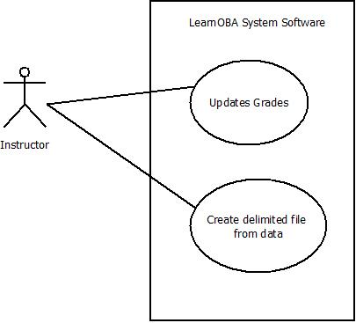

### Figure 14: Teacher Exports Scores Use Case Diagram

# 15 Teacher Adds a Question to an Assignment

Scenario: Mr. Klein has been going through and observing his exams. He realizes that his midterm is far too short for the time slot that has been given to the students so he would like to add some questions. Mr. Klein goes to his desktop and starts up LearnOBA. He selects his appropriate class and the exam. He chooses to add a question and enters in all the question details and the skills assigned to the question.

|  |  |
| --- | --- |
| Use Case Name: | Add Question to assignment |
| Related Requirements: | Adding skills and modifying outcomes |
| Goal in Context: | Questions are allowed to be added to an assignment for a particular class. |
| Preconditions: | LearnOBA must be installed on the instructor’s computer, class has to have been added, and exam has to have been added to that class. |
| Successful End Condition: | Questions are successfully added to an assignment. |
| Failed End Condition: | Questions were not added to the assignment. |
| Primary Actors: | Instructor |
| Secondary Actors: | Database |
| Trigger: | An instructor chooses to add more questions to a created assignment. |
| Main Flow: | 1)Teacher starts up LearnOBA  2) Teacher selects the appropriate class  3)Teacher selects the correct assignment  4) Teacher chooses to add a question to the exam  5) Teacher fills out appropriate info pertaining to the assignment  6) Instructor saves the question and its stored in the database to that particular assignment. |
| Extensions: | N/A |

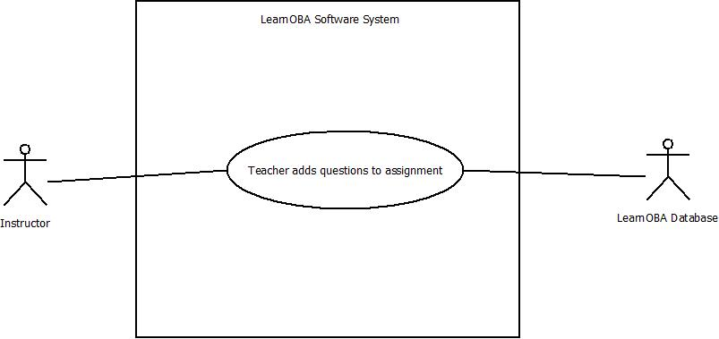

### Figure 15: Teacher Adds Questions to Assignment Use Case Diagram

# 16 Teacher Removes a Question from an Assignment

|  |  |
| --- | --- |
| Use Case Name: | Remove Question From assignment |
| Related Requirements: | Adding skills and modifying outcomes |
| Goal in Context: | Questions are allowed to be removed from an exam for a particular class. |
| Preconditions: | LearnOBA must be installed on the instructor’s computer, class has to have been added, and exam has to have been added to that class. |
| Successful End Condition: | Questions are successfully removed from an assignment. |
| Failed End Condition: | Questions were not removed from the assignment. |
| Primary Actors: | Instructor |
| Secondary Actors: | Database |
| Trigger: | An instructor chooses to remove questions to a created assignment. |
| Main Flow: | 1)Teacher starts up LearnOBA  2) Teacher selects the appropriate class  3)Teacher selects the correct assignment  4) Teacher chooses to remove a question to the assignment  5) Teacher selects questions to remove  6) Instructor saves the changes and its stored in the database to that particular assignment. |
| Extensions: | N/A |

Scenario: Dr. Foster has noticed that in previous semesters his students have struggled to finish their exams on time. He decides that it would be best to remove some questions from his exams to give students more time to finish. So Dr. Foster goes home and starts up his LearnOBA system. He selects the correct class and the exam that contains too many questions. He then selects specific questions to remove and clicks enter. The questions are removed from the database.

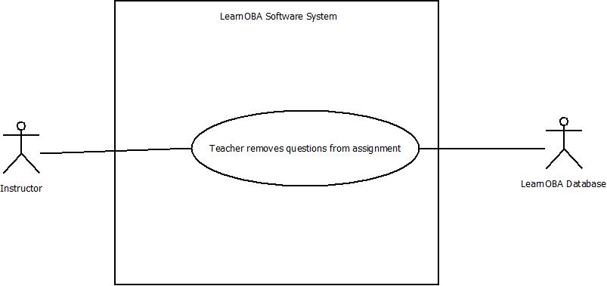

### Figure 16: Teacher Removes a Question Use Case Diagram

# 17 Teacher Adds an Assignment to a Class

|  |  |
| --- | --- |
| Use Case Name: | Add assignment to a particular class |
| Related Requirements: | Adding questions to an assignment, adding skills and modifying outcomes |
| Goal in Context: | Assignments are allowed to be added for a specific class |
| Preconditions: | LearnOBA must be installed on the instructor’s computer , class has to have been added |
| Successful End Condition: | Assignments are successfully added to a particular class. |
| Failed End Condition: | Assignment was not added to the class. |
| Primary Actors: | Instructor |
| Secondary Actors: | Database |
| Trigger: | An instructor chooses to add assignments to a particular class. |
| Main Flow: | 1)Teacher starts up LearnOBA  2) Teacher selects the appropriate class  3)Teacher selects to add assignment  4) Teacher saves that assignment to the database for that particular class. |
| Extensions: | N/A |

Scenario: Dr. Foster has noticed that the midterm is too much information for one test. So for this semester he would like to break the midterm up into two separate tests. So what he does is he goes and starts up his LearnOBA software system and selects the appropriate class. He then chooses to add an exam. He saves this to the database and then chooses to add another exam and saves this one as well. Now there are two exams stored for that class on the LearnOBA system.

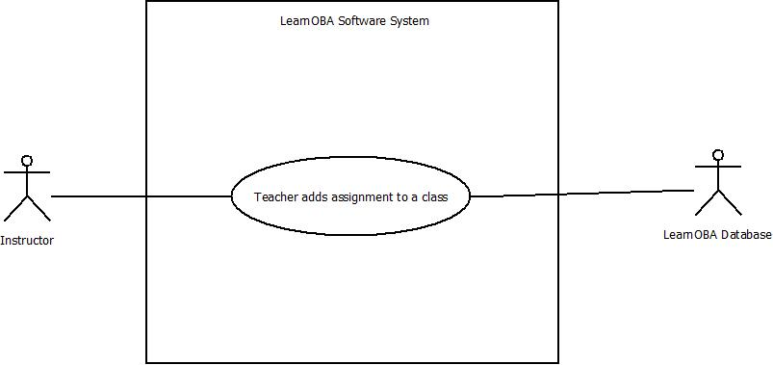

### Figure 17: Teacher Adds an Assignment Use Case Diagram

# 18 Teacher Removes an Assignment from a Class

|  |  |
| --- | --- |
| Use Case Name: | Remove assignment from a particular class |
| Related Requirements: | Adding and removing questions to an assignment, modifying outcomes, adding skills to a question, adding questions to an assignment. |
| Goal in Context: | Assignments are allowed to be removed from a specific class |
| Preconditions: | LearnOBA must be installed on the instructor’s computer, class has to have been added, and assignments must have been added to that class. |
| Successful End Condition: | Assignments are successfully removed from a particular class. |
| Failed End Condition: | Assignment was not successfully removed for a particular class. |
| Primary Actors: | Instructor |
| Secondary Actors: | Database |
| Trigger: | An instructor chooses to remove assignments from a particular class. |
| Main Flow: | 1)Teacher starts up LearnOBA  2) Teacher selects the appropriate class  3)Teacher selects to remove assignment  4) Teacher saves the changes to the database for that particular class. |
| Extensions: | N/A |

Scenario: Dr. Ercal has decided that she has been too hard on her students when it comes to the length of their assignments. She would like to remove a couple assignments so the students will not be so overwhelmed. Dr. Ercal gets on LearnOBA and selects the appropriate class. She then clicks the correct assignment and chooses to remove the assignment. She clicks save and the assignment is then removed from the LearnOBA database.

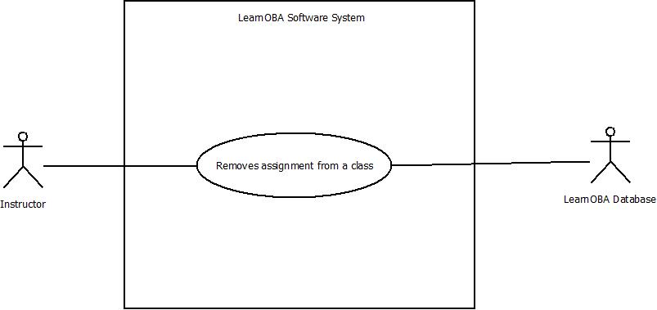

### Figure 18: Teacher Removes an Assignment Use Case Diagram

# 19 Teacher Removes a Class

Scenario: Dr. Mayer has now been officially been using the LearnOBA system for a year. It is a requirement by SIUE to obtain all academic data for up to a year. Dr. Mayer has received a notification from his LearnOBA system asking him if he would like to remove his classes from last year. He selects to remove all of his classes. All classes are removed from the system.

|  |  |
| --- | --- |
| Use Case Name: | Remove Class |
| Related Requirements: | N/A |
| Goal in Context: | Classes are removed from the LearnOBA system after a year has gone by. |
| Preconditions: | LearnOBA must be installed on the instructor’s computer and class has to have been added, and a year has to have gone by. |
| Successful End Condition: | Class is successfully removed from the Database. |
| Failed End Condition: | Class was not successfully removed from the database. |
| Primary Actors: | Instructor |
| Secondary Actors: | Database |
| Trigger: | A year has gone by. |
| Main Flow: | 1)Teacher starts up LearnOBA  2) Notification is sent to teacher by LearnOBA  3)Teacher selects to remove all classes from last year.  4) Classes are removed from database from previous year. |
| Extensions: | 3.1)Teacher selects to remove specific classes from the database. |

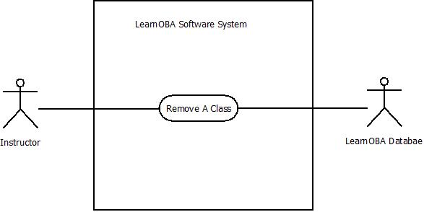

### Figure 19: Teacher Removes a Class Use Case Diagram